A (A-Star) Algorithm*
Aim
To implement the A* Search Algorithm using Python.
Objective
- To find the shortest path between two nodes.
- To use heuristic values for efficient path finding.
Algorithm
- Initialize the open and closed lists.
- Add the start node to the open list.
- Select the node with the lowest f(n)=g(n)+h(n).
- If the goal node is reached, stop.
- Otherwise, generate successor nodes.
- Compute g, h, and f values.
- Add successors to the open list.
- Repeat until the goal is found.

FLOW CHART
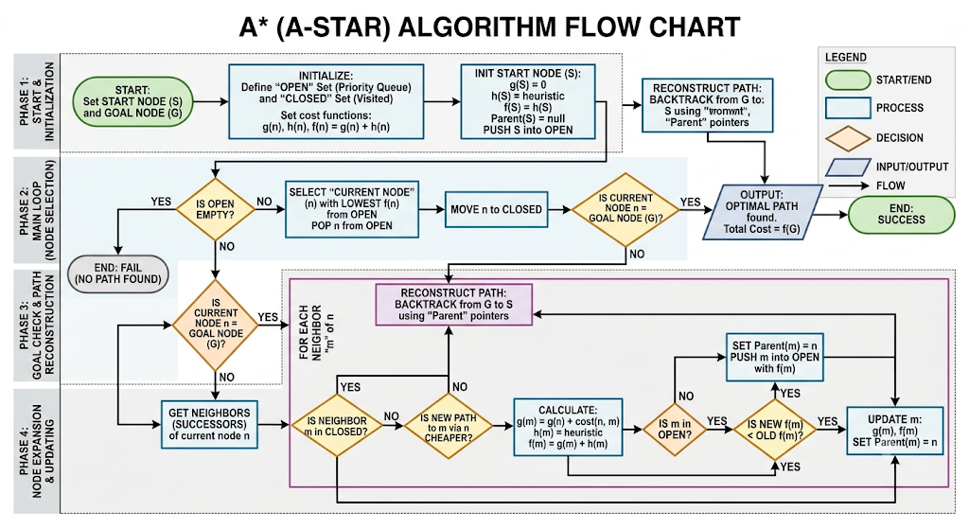
PYTHON CODE
from queue import PriorityQueue

graph = {
'A': {'B': 1, 'C': 3},
'B': {'D': 3, 'E': 6},
'C': {'F': 5},
'D': {},
'E': {'F': 2},
'F': {}
}

heuristic = {
'A': 6,
'B': 4,
'C': 4,
'D': 2,
'E': 1,
'F': 0
}

def astar(start, goal):
pq = PriorityQueue()
pq.put((0, start))
cost = {start: 0}
parent = {start: None}

while not pq.empty():
_, current = pq.get()

if current == goal:
break

for neighbor, weight in graph[current].items():
new_cost = cost[current] + weight

if neighbor not in cost or new_cost < cost[neighbor]:
cost[neighbor] = new_cost
priority = new_cost + heuristic[neighbor]
pq.put((priority, neighbor))
parent[neighbor] = current

path = []
node = goal

while node:
path.append(node)
node = parent[node]

path.reverse()
return path

print("Shortest Path:", astar('A', 'F'))

RESULT

